Economic Reforms in India

Meaning of Economic Reforms
Economic Reforms refer to the fundamental changes that were launched in 1991 with the plan of liberalising the economy and to quicken its rate of economic growth. The Narasimha Rao Government, in 1991, started the economic reforms in order to rebuild internal and external faith in the Indian economy.
The reforms intended at bringing in larger cooperation of the private sector in the growth method of the Indian economy. Policy changes were proposed with regard to technology up gradation, industrial licensing, removal of restrictions on the private sector, foreign investments and foreign trade. The essential features of the economic reforms are – Liberalisation, Privatisation and Globalisation, commonly known as LPG.

To put it in other words, “Economic reforms” normally indicates to deregulation or at times to decrease in the size of government, to eliminate deformities caused by management or the presence of administration, rather than current or raised regulations or government plans to lessen perversions created by market failure.
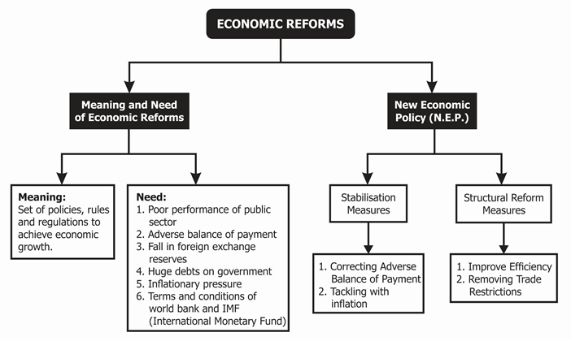

Need for Economic Reforms
- Poor Performance of the Industrial Sector
- Adverse Balance of Payments
- Rise in Fiscal Deficit
- Inflation
- The Gulf War

Examples of Economic Reforms
- Liberalisation
- Privatisation
- Globalisation

Why were Economic reforms introduced in India?
Economic reforms were introduced in India because of the following reasons:
Poor performance of the public sector
- Public sector was given a role important in development policies during 1951-1990.
- However the performance of the majority of public enterprises was disappointing.
- They were incurring huge losses because of inefficient management.
Adverse Balance of payments Or Imports exceeded exports
- Imports grew at a very high rate without matching the growth of exports.
- Government could not restrict imports even after imposing heavy tariffs and fixing quotas.
- On the other hand, Exports was very less due to the low quality and high prices of our goods as compared to foreign goods.
Fall in foreign exchange reserves
- Foreign exchange (foreign currencies) reserves, which government generally maintains to import petrol and other important items, dropped to levels that were not sufficient for even a fortnight.
- The government was not able to repay its borrowings from abroad.
Huge debts on government
- Government expenditure on various developmental works was more than its revenue from taxation etc.
- As a result, the government borrowed money from banks, public and international financial institutions like IMF etc.
Inflationary pressure
- There was a consistent rise in the general price level of essential goods in the economy.
- To control inflation, a new set of policies were required.
Terms and conditions of world bank and IMF
- India received financial help of $7 billion from the World Bank and IMF on an agreement to announce its New Economic Policy

The Crisis of 1991 and the Reforms
The crisis of 1991 happened largely due to inefficient management of the economy of India in the 1980s. The revenues that government was generating were not enough to meet the ever increasing expenses. Thus, the government had to borrow to pay for the debts and thus was caught in a term called debt-trap. Debt-trap is the deficit that occurs due to an increase in government expenses in comparison to the government’s revenue.
Due to the failure of earlier economic policies till 1990 there was a need for need for new economic policies. The situation was worsening as India had foreign reserves which could last only for the next two weeks. There was a shortage of new loans and Indian people living abroad (NRIs) were withdrawing money in large amounts.
There was a little confidence for international investors towards the Indian economy. These points will highlight the need for a new economic policy in India. Crisis in Gulf countries, increase in fiscal deficit, prices rising, the worse balance of payments, public sector units (PSUs) performing badly, and many more.

The Emergence of New Reforms
India approached the world and international monetary fund for loan and received $7 million to manage their crisis. As a result to this, international firms and agencies expected that India will open up the door in the country by removing various restrictions majorly on private sector and thereby removing the trade restrictions between India and the other foreign countries.
India agreed to the terms and conditions and as a result, new reforms were introduced. These economic reforms in India are structurally classified as liberalization, globalization, and privatization.

Liberalization
Liberalization was brought up with the fact that any restrictions which became a hindrance to development and growth will be put to an end. Largely, this reforms made government regulations and policies lose. It allowed for opening up of economic borders for foreign investment as well as multinationals.
There were many economic reforms introduced under liberalization. These included expansion of production capacity, abolishing industrial licensing by the government, de-reserving producing areas, and freedom to import goods.

Privatization
Privatization largely refers to giving more opportunities to the private sector, such that the role of the public sector is reduced. The main objectives of privatization are reducing the workload of the public sector, providing better goods and services to the end users, improving the government’s financial condition, and many more. Privatization is a way to allow the entry of foreign direct investments and bringing healthy competition into the economy.

Globalization
Globalization in simpler terms is to connect with the world. In this context, globalization means the integration of the economy of India with that of the world. Thus, it encourages private and foreign investment and also foreign trade. Globalization attempts to establish the links in such a way that the Indian happenings can be met by the world or vice versa.

Major Highlights on the Economic Reforms in India
- During the reform period, the growth in service was increasing, while the agriculture sector saw a decline, and the industrial sector was fluctuating.
- The opening up of the Indian economy led to a sharp increase in the FDIs and foreign exchange reserve.
- This foreign investment includes foreign institutional investment and direct investment.
- India is one of the successful exporters of engineering goods, auto parts, IT software, textiles during the time of the reforms.
- The price rise during the reforms was also kept under control.

Failures of the Economic Reforms in India
- The agriculture sector was neglected and the public investment in this sector was reduced and hence the infrastructure areas were affected.
- The subsidies on the fertilizers were removed and hence it led to an increase in the cost of production which affected many marginal and small farmers.
- Further, many policies were introduced which reduce the import duties on agriculture products, reduce the minimum support price increased the threat of international organizations competing with th3 the local farmers.
- The industrial sector saw uneven growth.
- The imports were made cheaper as a result of which the demand for the industrial goods reduced.
- The globalization which allowed for free trade between the countries affected adversely on the local industries and thus affected employment opportunities.
- The reforms led to an increase in economic colonialism.
- It also led to the erosion of culture.
- The investments in many infrastructural facilities like power supply were inadequate.

